Exercise-2_E-commerce Platform Search function
Asymptotic Notation
Big O Notation is used to describe the requitement of an algorithm. It denotes it’s run time and space occupied.
Linear Search is the algorithm which checks each element of the array and return found or not
Binary Search is the algorithm which divides the array into two halves and checks for the target element based on the presence of mid element. This is efficient in Sorted arrays

Scenario | Linear Search | Binary Search
Best case | O(1) - First element | O(1) - Middle element
Average case | O(n) | O(log n)
Worst case | O(n) | O(log n)

Product Class

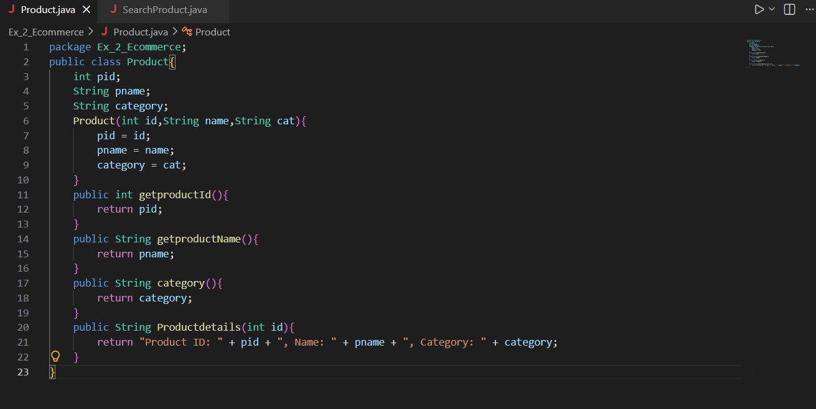

SearchProduct class
(linear search and binary search methods)
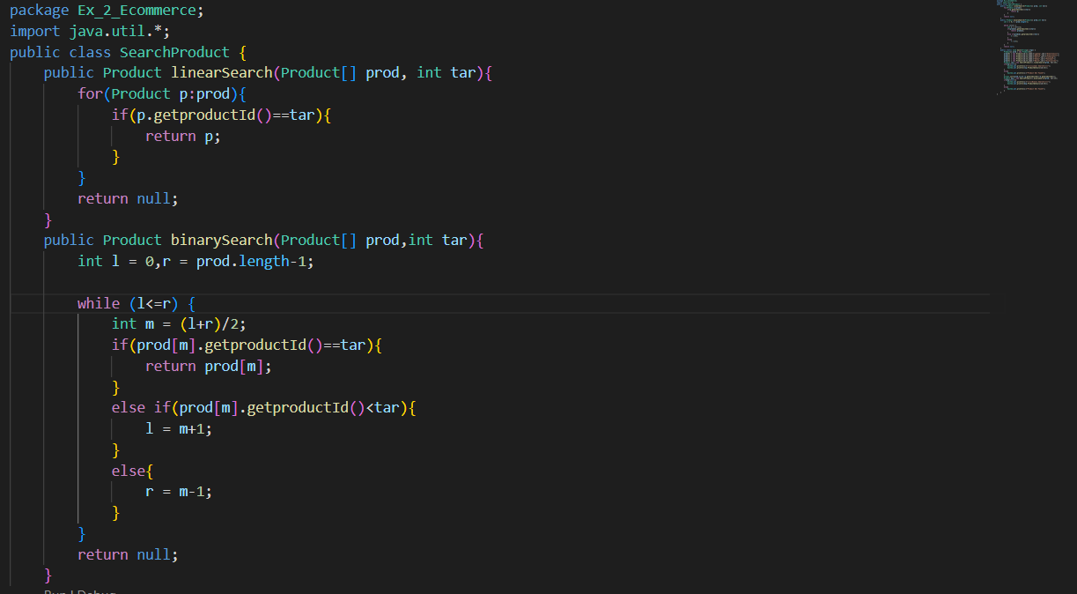

Main method
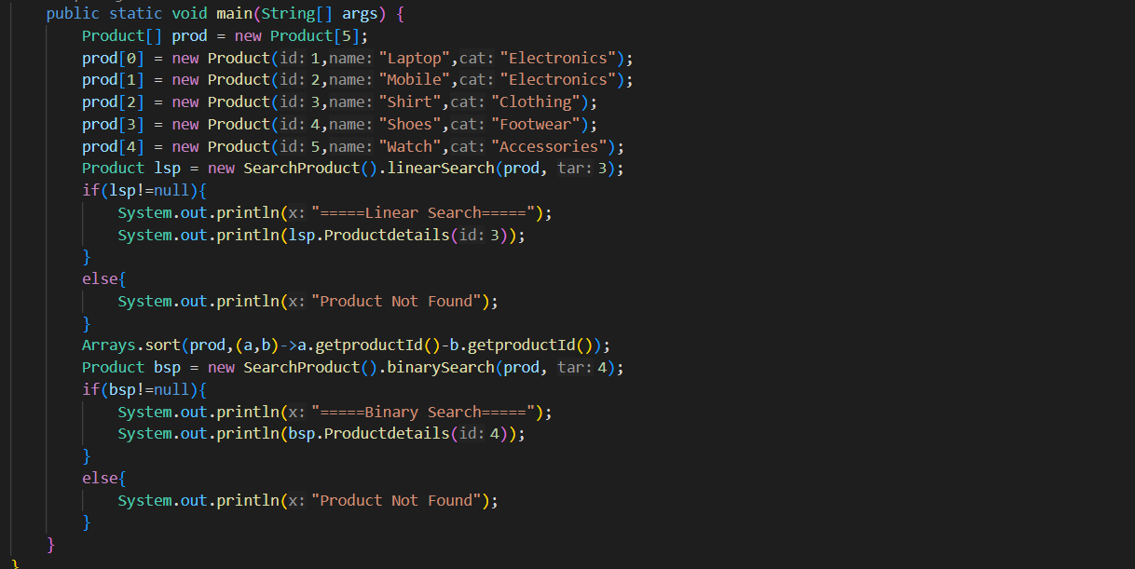

Output
